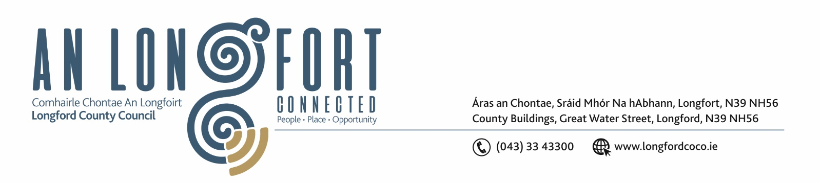

Please Note Commencement Time of Meeting – 2.30 p.m.

5u Marta 2020.

Chuig: Gach Ball don Chomhairle.

A Chomhairleoir,

Iarrtar ort bheith i láthair ag Cruinniú Chomhairle Chontae Longfoirt a tionólfar i Seomra na Comhairle, Aras an Chontae, Longford ar an Chéadaoin, 11u Marta 2020 ag 2.30 p.m chun gnó a dhéanamh d’réir an Chláir thíos.

You are requested to attend Meeting of Longford County Council to be held in the Council Chamber, Aras an Chontae, Great Water Street, Longford on Wednesday, 11th March 2020 at 2.30 p.m. to transact business, as set out on the Agenda hereunder.

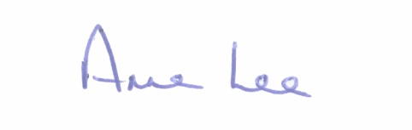
Mise le meas,

__________________
Anne Lee,
Meetings Administrator.

C L A R

2.30 p.m Music Generation – Presentation by Mary-Jane Sweeney, Music Generation Officer.

- Confirmation of Minutes of the following meetings of Longford County Council

- Longford County Council Meeting held on the 15th January 2020.
- Special Meeting held on the 25th February 2020.
- Adjourned Special Meeting held on the 2nd March 2020.
copies enclosed.

- Matters arising from Minutes.

- Declaration of Interest by Members.

- To note Management Report - to follow.

5. To note adopted Minutes of Corporate Policy Group Meeting held on
11th December 2019 and 15th January 2020 - enclosed.

6. Community, Corporate and Enterprise.

- Consideration and adoption of Draft Standing Orders - Strategic Policy Committees – enclosed.

- Approval to the appointment of Sectoral Representatives to the following Strategic Policy Committees –

- Strategic Infrastructure – Stephanie Igoe and Tess Murphy
- Governance - Brendan Murtagh and Pamela Martin

Update on outstanding Nominees to the following Strategic Policy Committees –

- Placemaking - Development / Construction
- Governance - Trade Union

- Recommendation from Placemaking Strategic Policy Committee regarding amendment to Business Incentive Scheme.

- Consideration of Progress Report on Irish Language Scheme (Official Languages Act, 2003)
- report enclosed.

- (i) Date for 2020 Annual Meeting of Longford County Council.
(ii) Date for 2020 Cathaoirleach Awards Ceremony.

- Notices of Motions submitted by Councillors, as listed hereunder –

Councillor Garry Murtagh.

“I am calling on Longford County Council to invest in a countywide communication service, to connect and deliver messages from agencies such as Garda Emergency/Text alerts, County Council and Local Community Groups.
A free service for the people of Longford thus supporting the efforts of the Garda, Joint Policing committee (JPC) and the wider communities within the county of Longford.
Monaghan County Council are running a similar initiative (delivered by Komeer) which has proven to be very successful in providing regular communications to its members.
Komeer are happy to deliver a presentation to Longford County Council/JPC.”

Councillor Gerard Farrell.
“That Longford County Council writes to the Department of Communications, Climate Action and Environment, Minister Bruton and Kieran Mulvey, Just Transition Commissioner, asking that Lanesboro Power Station be retained in the community after the finishing of peat production.”

Councillor Mark Casey.
“That this Council writes to the ESB, Department of Communications, Climate Action and Environment and Kieran Mulvey to –
- Retain the Power Station in Lanesborough until all various outcomes are considered.
- That more funding be made available for Just Transition.”

Councillor Seamus Butler.
“That Longford County Council should provide serviced overnight facilities for RUVs and camper vans. This will mitigate against the blight of such vehicles causing nuisance by parking in public areas such as Clondra Harbour. It will also attract a category of tourist that is not currently catered for adequately in the County.”

7. Finance and Regeneration.

- Presentation on the Capital Budget 2020-2022.

- Notices of Motions, submitted by Councillors, as listed hereunder -

Councillor Micheál Carrigy.

“I call on the Department of Finance to extend the Living City Initiative to all urban areas in Longford Town and County to help regenerate our empty retail and housing stock.”

8. Strategic Infrastructure and Climate Change.

- To note Planning Applications received since last meeting of the Council.

- Update on preparation of Draft County Development 2021 – 2027.

- Consideration of Adoption of Part 8 Report (Planning and Development Act
2000 (as amended) and Planning and Development Regulations 2001) (as amended) in respect of the construction of 2 No. Light Industrial/Commercial Warehousing Units at Knock, Lanesboro, County Longford - details attached.

- Notices of Motions, submitted by Councillors, as listed hereunder –

Councillor Micheál Carrigy

“I call on Longford County Council to seek additional funding from the OPW to carry out major drainage works on the River Camlin and its tributaries.”

9. General.
- Correspondence – circulated
- Letter dated 15th January 2020 received from the Office of the Minister for Agriculture, Food and the Marine regarding Single Farm Payments.
- Letter dated 29th January 2020 received from Longford Community Resources clg regarding the Community House in MacEoin Park, Longford.
- Letter dated 26th February 2020 received from the Office of the Minister for Finance and Public Expenditure and Reform regarding Help to Buy initiative.

(b) Notices of Motions, submitted by Councillors, as listed hereunder -
Councillor Micheál Carrigy.
“I call on the incoming Government to provide the funds necessary to fulfil the amount of Home Help hours needed to help our elderly on their homes.”

10. Training –

Consideration of Report from Corporate Policy Group.

11. Votes of sympathy.

